CAPSTONE PROJECT
Automated finance dashboard for small business

Python project
Reference document from jupyter notebook
Code1
Import pandas as pd
Code2
Df=pd.read_csv(“marketing.csv”)
Code3
Df

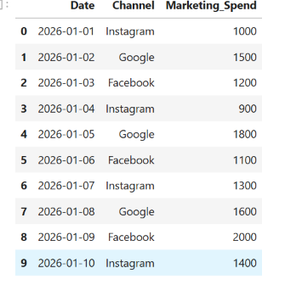
Code4
df.dtypes
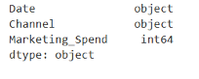

#code5
Df.shape
output
(10,3)
#code6
Df.head()
Output
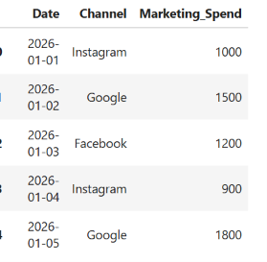
#code7
Df.tail()
output
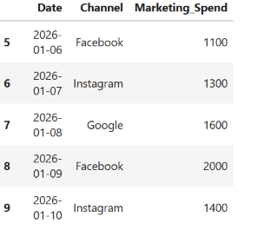
#code8
Df.describe()
OUTPUT
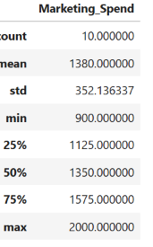
# Code 9
print("Missing values in each column:")
print(df.isnull().sum())
OUTPUT
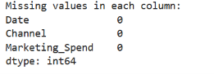
# Code 10
df.duplicated().sum()
OUTPUT
np.int64(0)

#11
Df.info()
OUTPUT
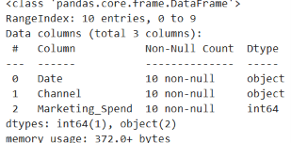

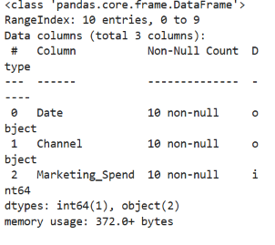
# Code 12
print("Marketing Channels:")
print(df["Channel"].value_counts())

print("\nTop Marketing Channels:")
print(df["Channel"].value_counts().head(10))
OUTPUT

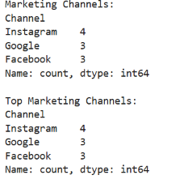
# Code 13
print("Total Marketing Spend:")
print(df["Marketing_Spend"].sum())

print("\nAverage Marketing Spend:")
print(df["Marketing_Spend"].mean())
OUTPUT

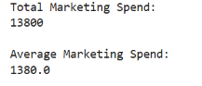
# Code 14
# Clean text columns
text_columns = ["Channel"]
for col in text_columns:
df[col] = df[col].astype(str).str.strip()
print("Text columns cleaned successfully!")
OUTPUT
Text columns cleaned successfully!

# Code 15
# Check Invalid Marketing Spend
print(
"Negative Marketing Spend values:",
(df["Marketing_Spend"] < 0).sum()
)
OUTPUT

Negative Marketing Spend values: 0

# Code 16
# Basic Financial/Business Analysis
total_marketing_spend = df["Marketing_Spend"].sum()
print("Total Marketing Spend:", total_marketing_spend)
OUTPUT
Total Marketing Spend: 13800

# Code 17
average_marketing_spend = df["Marketing_Spend"].mean()
print("Average Marketing Spend:", average_marketing_spend)
OUTPUT
Average Marketing Spend: 1380.0

# Code 18
highest_marketing_spend = df["Marketing_Spend"].max()
print("Highest Marketing Spend:", highest_marketing_spend)
OUTPUT
Highest Marketing Spend: 2000

# Code 19
lowest_marketing_spend = df["Marketing_Spend"].min()
print("Lowest Marketing Spend:", lowest_marketing_spend)
OUTPUT
Lowest Marketing Spend: 900

# Code 20
# Total Number of Marketing Record
total_records = len(df
print("Total Marketing Records:", total_records)
OUTPUT
Total Marketing Records: 10

# Code 21
# Calculate Average Marketing Spend

average_spend = df["Marketing_Spend"].mean()

print("Average Marketing Spend:", average_spend)
OUTPUT
Average Marketing Spend: 1380.0

# Code 22
# GROUP BY Analysis
channel_summary = df.groupby("Channel")["Marketing_Spend"].agg(
Number_of_Records="count",
Total_Marketing_Spend="sum",
Average_Spend="mean"
).sort_values(
"Total_Marketing_Spend",
ascending=False
)
Channel summery
OUTPUT

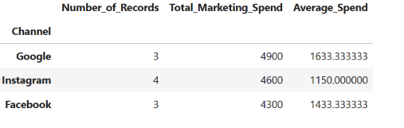

# Code 23
# Marketing Spend Summary by Channel

channel_summary = df.groupby("Channel")["Marketing_Spend"].agg(
Number_of_Records="count",
Total_Marketing_Spend="sum",
Average_Spend="mean"
).sort_values(
"Total_Marketing_Spend",
ascending=False
)
channel_summary
OUTPUT

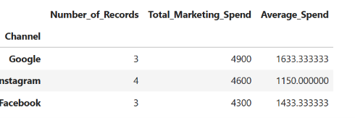
# Code 24
# Marketing Spend Summary by Channel
channel_spend = df.groupby("Channel")["Marketing_Spend"].sum()

channel_spend
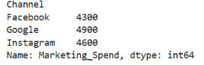
# Code 25

import matplotlib.pyplot as plt
import seaborn as sns

# Code 26
# Total Marketing Spend by Channel
plt.figure(figsize=(12, 6))
sns.barplot(
x="Channel",
y="Marketing_Spend",
data=df
)
plt.title("Total Marketing Spend by Channel")
plt.xlabel("Marketing Channel")
plt.ylabel("Marketing Spend")
plt.xticks(rotation=45)
plt.tight_layout()
plt.show()
OUTPUT

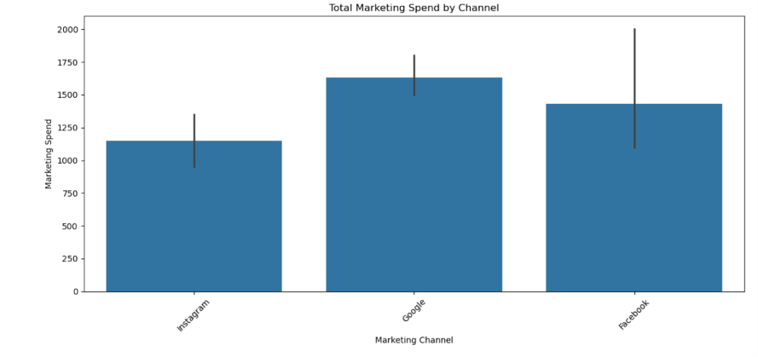
# Code 27
# Marketing Spend by Channel
channel_summary["Total_Marketing_Spend"].plot(
kind="bar",
figsize=(12, 6)
)
plt.title("Total Marketing Spend by Channel")
plt.xlabel("Channel")
plt.ylabel("Total Marketing Spend")
plt.xticks(rotation=45)
plt.tight_layout()
plt.show()
OUTPUT

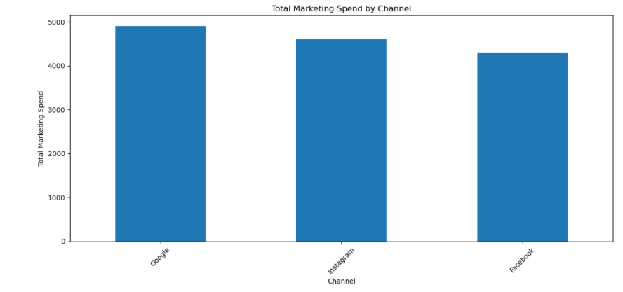
# Code 28
# Average Marketing Spend by Channel

channel_summary["Average_Spend"].plot(
kind="bar",
figsize=(10, 6)
)
plt.title("Average Marketing Spend by Channel")
plt.xlabel("Channel")
plt.ylabel("Average Marketing Spend")
plt.xticks(rotation=45)
plt.tight_layout()
plt.show()

OUTPUT

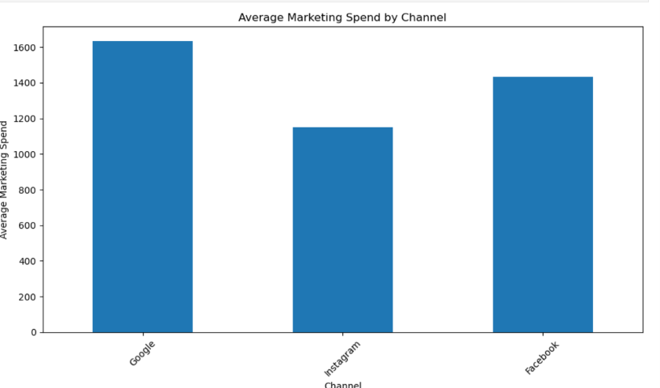
# Code 29
# Convert Date column
df["Date"] = pd.to_datetime(df["Date"])
# Marketing spend by date
date_summary = df.groupby("Date")["Marketing_Spend"].sum()
plt.figure(figsize=(12, 6))
sns.lineplot(
x=date_summary.index,
y=date_summary.values,
marker="o"
)
plt.title("Total Marketing Spend Over Time")
plt.xlabel("Date")
plt.ylabel("Marketing Spend")
plt.grid(True)
plt.tight_layout()
plt.show()
OUTPUT

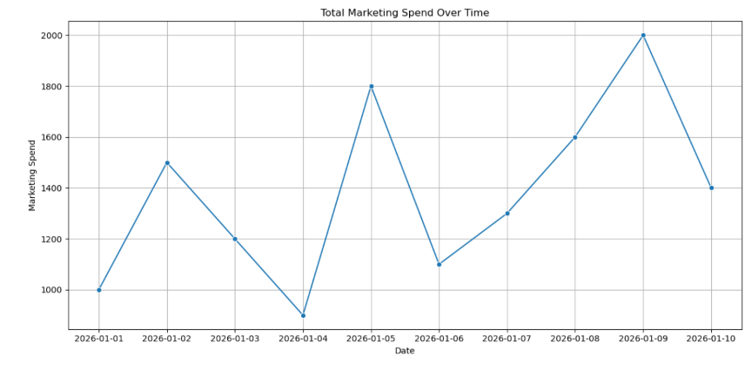
# Code 30
# Marketing Spend Distribution
plt.figure(figsize=(10, 6)
plt.hist(
df["Marketing_Spend"],
bins=30,
edgecolor="black"
)

plt.title("Marketing Spend Distribution")
plt.xlabel("Marketing Spend")
plt.ylabel("Number of Records")
plt.grid(True)
plt.tight_layout()
plt.show()

OUTPUT

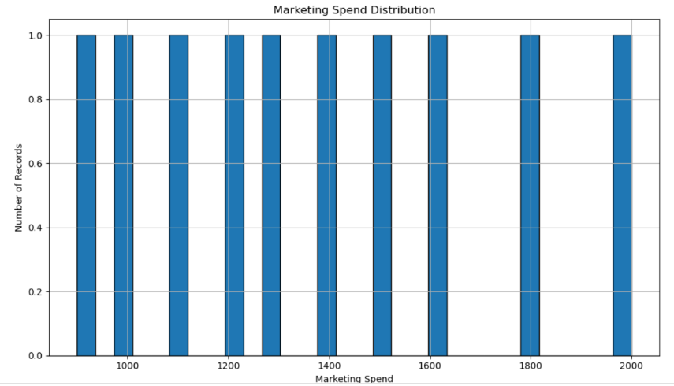
# Code 31
# Top Marketing Channels

top_channels = (
df.groupby("Channel")["Marketing_Spend"]
.sum()
.sort_values(ascending=False)
)

top_channels
OUTPUT

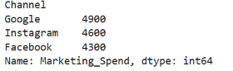

# Code 32
# Top Marketing Channels by Spend
plt.figure(figsize=(12, 6))
top_channels.plot(kind="bar")
plt.title("Marketing Channels by Total Spend")
plt.xlabel("Marketing Channel")
plt.ylabel("Total Marketing Spend")
plt.xticks(rotation=45)
plt.tight_layout()
plt.show()

OUTPUT

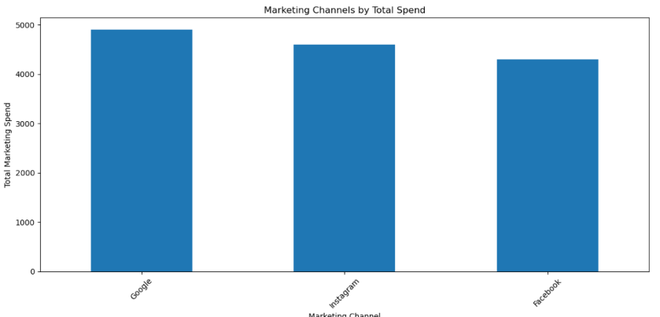
# Code 33
# Marketing Spend by Channel - Horizontal Bar Chart

channel_spend = (
df.groupby("Channel")["Marketing_Spend"]
.sum()
.sort_values()
)
plt.figure(figsize=(10, 6))
channel_spend.plot(kind="barh")
plt.title("Marketing Spend by Channel")
plt.xlabel("Total Marketing Spend")
plt.ylabel("Marketing Channel")
plt.tight_layout()
plt.show()
OUTPUT

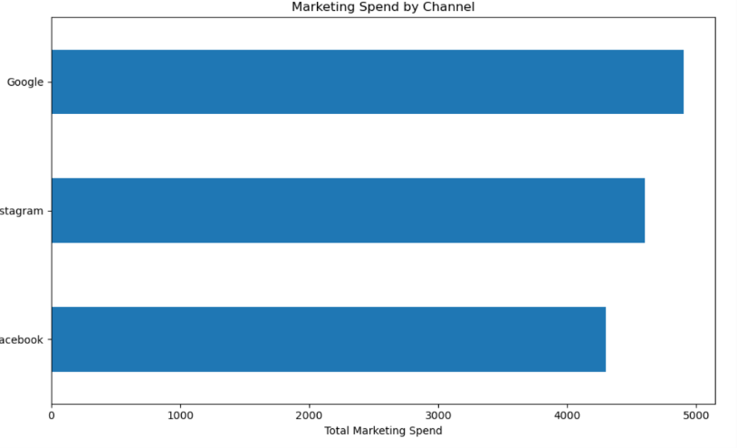
# Code 34
# Marketing Spend Distribution by Channel

channel_spend = df.groupby("Channel")["Marketing_Spend"].sum()
plt.figure(figsize=(8, 8))
plt.pie(
channel_spend,
labels=channel_spend.index,
autopct="%1.1f%%"
)
plt.title("Marketing Spend Distribution by Channel")
plt.tight_layout()
plt.show()

OUTPUT

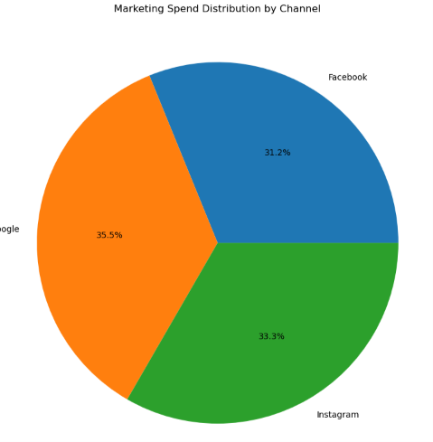
# Code 35
# FINANCIAL / MARKETING DASHBOARD KPIs
print("========== MARKETING DASHBOARD KPIs ==========")
print("Total Marketing Spend :", total_marketing_spend)
print("Average Marketing Spend :", average_marketing_spend)
print("Highest Marketing Spend :", highest_marketing_spend)
print("Lowest Marketing Spend :", lowest_marketing_spend)
print("Total Marketing Records :", total_records)
OUTPUT

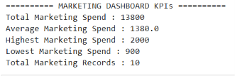
# Code 36
# Channel with Highest Total Marketing Spend
top_channel = channel_summary[
"Total_Marketing_Spend"
].idxmax()
top_channel_spend = channel_summary[
"Total_Marketing_Spend"
].max()
print("Top Marketing Channel:", top_channel)
print("Marketing Spend:", top_channel_spend)
OUTPUT
Top Marketing Channel: Google
Marketing Spend: 4900

# Code 37
# Channel with Lowest Total Marketing Spend

lowest_channel = channel_summary[
"Total_Marketing_Spend"
].idxmin()
lowest_channel_spend = channel_summary[
"Total_Marketing_Spend"
].min()
print("Lowest Marketing Channel:", lowest_channel)
print("Marketing Spend:", lowest_channel_spend)
OUTPUT



# Code 38
# Date with Highest Marketing Spend
top_date = date_summary.idxmax()
top_date_spend = date_summary.max()
print("Date with Highest Marketing Spend:", top_date)
print("Marketing Spend:", top_date_spend)
OUTPUT
Date with Highest Marketing Spend: 2026-01-09 00:00:00
Marketing Spend: 2000

# Code 39
# Save cleaned dataset
df.to_csv(
"marketing_cleaned.csv",
index=False
)
print("Cleaned marketing dataset saved successfully!")
OUTPUT

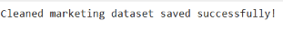

# Code 40
# Final Summary
final_summary = {
"Total Marketing Records": total_records,
"Total Marketing Spend": total_marketing_spend,
"Average Marketing Spend": average_marketing_spend,
"Highest Marketing Spend": highest_marketing_spend,
"Lowest Marketing Spend": lowest_marketing_spend,
"Top Marketing Channel": top_channel,
"Lowest Marketing Channel": lowest_channel,
"Highest Spend Date": top_date
}
final_summary
OUTPUT

